

**Questions Bank Generation System**

**Supervisors**

**Dr. Ahmed Ezz**

**Eng. Sara Hamdy**

**By**

**1-Shenouda Gad Fakhry Gad 20-00673**

**2-Ragab hossny Ahmed hassan 20-00908**

**3-Kerolos Basem Tawdrous Louka 2001497**

**4-Hazem khairy abdelhamid Soliman 20-0853**

**5-Antonious mokles sedrak 20-00331**

**6-Mohamed alaa anter ahmed 20-01454**

**7-Felotas Waheed zekry 20-01645**

**Acknowledgement:**

First, we want to thank God for his grace and for his support to us throughout our years in college and our graduation project to complete this stage of our life successfully. We have put efforts into this project. However, this was not enough without the support of many individuals and organizations and the assistance of the Egyptian University for E-learning especially the Sohag Center in order for us to reach this level of awareness. We would like to express our deep gratitude to our Project Supervisor Dr. Ahmed Ezz to follow us and provide guidance throughout this project. We are also especially indebted to expressing our thanks to Eng.Sara Hamdy for her constant guidance and supervision. Finally, we would like to express our gratitude to everyone who helped us during the graduation project.

**Abstract:**

**•** It is an electronic question bank that builds questions programmatically without the need to write the questions manually, which makes it more efficient and accurate without wasting time and effort. It also covers all aspects of the subject through the presence of a large number of different questions that you can get answers to have great knowledge about the subject. Which you are looking for.

**•**The question bank generation system contains different questions that have the same accuracy and experience and revolve around one topic to include the information correctly and understand the topic you want to understand without overlapping the information you have.

**Table of content**

**Chapter 1: Introduction**

1.1 History………………………………………………………………………..………...9

1.1.1 Genesis of Computer-Assisted Instruction (1960s) ....................................9

1.1.2 Algorithmic Refinement (1970s-1980s) .……….……………………………..….……..9

1.1.3 Proliferation in Education (1990s)……………..…………………………………….……..9

1.1.4 Technological Advancements in the Digital Era (21st Century)……..….……...9

1.2 The stages of development for the Question Bank……………….……..10

1.2.1 Conception and Ideation………………………….………………………………….…..……..10

1.2.*2* Research and Analysis………….………………………………………….……….…….……….10

1.2.3 Algorithm Development……………….…………………………………………….…..…..….10

1.2.4Prototype Creation………………,…………….…………………………………………………..10

1.2.5 Testing and Validation..………..…………….……….……………………………………..……10

1.2.6 Refinement and Optimization….………..……..……………………..………………………11

1.2.7 Deployment and Integration……….……………………………………………………..……11

1.2.8 Training and Support……………………………………………………………………….….…..11

1.2.9 Continuous Improvement…………….…….………………………………………..…………11

**Chapter 2 Problem and solution**

2.1 problems…………………………………………………….……………….………..13

2.1.1The student………………………….……………….………………………………………………..13

2.1.2professor and teacher……………………….….…………………………………….………….13

2.2 The solution………………………………………….………………………………..………………….13

The general solution for students and professors…………………………….……14

2.1.1The student……………………..……………………………………………………………………….14

2.1.2professor and teacher………….…….……………………………………………….………….14

3.1 Electronic system ……………………………..…………….…………….………15

proposed electronic system………………………………….…………….……………15

3.1.1Electronic exam system……………………………………….………..…………….16

3.1.1Question generation systems…………………………..…………….………………….16

3.1.2 Exam generation system………………………….………………………………..………16

3.1.3 Exam correction system…………………………….………………………………………16

3.1.2Database server……….………………………………….………………………………………16

3.2.1 Question Bank……………………………………………………………………………………..16

3.2.2Student……………………………………………………………………………………………….16

3.2.3Exams………………………………………………………………………………………………….16

3.2 Flowchart……………….………………..…………………………………………..17

3.3 Algorithm for flowchart .……..……………..…………………………………18

3.4 Pseudocode for Flowchart………………….………………………………….19

**Chapter 3: Project codes**

link Java together with JDBC………….……………………………………………..21

creates a table…………….………………………………………………………………..21

The Questions………….……………………………………………………………………22

**1-Question (1)……………………………….………………………………………… ………..22**

Output question (1)……………………………………….……………………….………….23

Output question (1) in text file……………………………………………………………24

**2-Question (2) ………………………… …………………………………..………….………..25**

Output question (2)…………….…………..………………..……………………..………..26

Output question (2) in text file…………………………………..………………..……..27

**3-Question (3)…………………………………..………………………………………………..28**

Output question (3)……………… …………………………………………………………..29

Output question (3) in text file……………………………………………………..……30

**4-Question (4)…………………………………………………….……………………………..31**

Output question (4)………….………….….……………………..………………………..32

Output question (3) in text file………………………….………………………………33

**5-Question (5)…………………..……………….……………………………………………..34**

Output question (5)…………...…..………………………………………………………..35

Output question (5) in text file……………….…………………………………………36

**6-Question (6)…………………………………………………………………………………..37**

Output question (6)……………..………………..………… ……………………………..38

Output question (6) in text file………………………………………………….………39

**7-Question (7)…………………………..……………………………………………………..40**

Output question (7)…………..………..………………….……………..………………..41

Output question (7) in text file…………………………………………………………42

**8-Question (8)…………………………………..……………………………………………..43**

Output question (8)……………………………………………….………………………..44

Output question (8) in text file…………………………………………………………45

**9-Question (9)……………………………………………………….………………………..46**

Output question (9)………………………………………………………………………..47

Output question (9) in text file……………………………………………..………..48

**10-Question (10)……………………………………… ……………..……………….……..49**

Output question (10)………………………………………………………………………50

Output question (10) in text file……………………………………….…………….51

**11-Question (11)……………… ………………………………………….…………………..52**

Output question (11)…………………………….………………………………………..53

Output question (11) in text file………………………………………………………54

**12-Question (12)…………………..…………………………………………………………..55**

Output question (12)…………….………………………………………………………..56

Output question (12) in text file………………………………………………………57

**13-Question (13)……………………………….……………………………….……………..58**

Output question (13)………………………………………………….…………………..59

Output question (13) in text file………………………………………………………60

**14-Question (14)………………………………………………………………………………..61**

Output question (14)…………………….………………………………….……………..62

Output question (14) in text file……………………………………….………………63

**15-Question (15)……………………………………………………………………….……….64**

Output question (15)……….……………………………………………………….……..65

Output question (15) in text file……………………………………………………….66

**16-Question (16)……………..……………………………….………………………………..67**

Output question (16)……………………………….……………………………………...68

Output question (16) in text file……………………………………………………….69

**17-Question (17)…………………………………………………………………………………70**

Output question (17)……………………..…………………………………………….…..71

Output question (17) in text file…..……………………………………………………72

**18-Question (18)…………………………………………………………………………………73**

Output question (18)…………………………………………….………………………….74

Output question (18) in text file…………….…………………………………………75

**19-Question (19)………………………………………………………………………………..76**

Output question (19)…………………………..…………………………………………..77

Output question (19) in text file………………….……………………………………78

**Conclusion and Future Work**

Conclusion…………………..…………………………..…………….……………………79

Future……………………………..……………………………………………………..……80

**Figures**

The general solution for students and professors………………………………………….14

Electronic system ……………………………..……………...…………………………15

Flowchart……………….………………..………………………….………………………17

Algorithm for flowchart .……..……………..……………………..…………………18

Pseudocode for Flowchart………………….…………………………………………19

**Chapter 1 Introduction**

**1.1 History of question bank generation system**

**1-Genesis of Computer-Assisted Instruction (1960s):**

In the 1960s, the inception of computer-assisted instruction laid the groundwork for question bank generation systems. These early systems were basic, storing questions manually entered into databases. They represented an initial foray into automating assessment processes, offering educators digital alternatives to traditional paper-based tests.

**2-Algorithmic Refinement (1970s-1980s):**

Throughout the 1970s and 1980s, significant strides were made in refining algorithms for question generation. Researchers delved into automating this process by developing algorithms capable of analyzing educational content, identifying key concepts, and formulating questions dynamically. These advancements marked a shift towards more sophisticated question bank generation systems.

**3-Proliferation in Education (1990s)**

The 1990s witnessed the widespread adoption of question bank generation systems in educational settings. With the rise of the internet and e-learning platforms, these systems became indispensable tools for educators. They enabled the creation of personalized assessments tailored to individual learners, facilitating instant feedback and revolutionizing the assessment landscape.

\***4-Technological Advancements in the Digital Era (21st Century):**

In the 21st century, question bank generation systems have undergone continuous technological evolution. Integrating adaptive learning technologies and leveraging big data analytics, these systems provide deeper insights into student performance. Seamless

integration with learning management platforms streamlines the assessment process, underscoring a concerted effort to harness technology for enriched teaching and learning experiences.

**1.2 The stages of development for the Question Bank Generation system.**

**1-Conception and Ideation:**

The process begins with conceptualizing the idea of automating the creation of question banks for educational purposes. Developers outline the objectives and functionalities of the system.

**2-Research and Analysis:**

Extensive research is conducted to understand the principles of question generation and educational content. This involves studying existing algorithms and methodologies while identifying gaps and areas for improvement.

**3-Algorithm Development:**

Based on research findings, algorithms are developed to automate the process of generating questions. These algorithms analyze educational content, extract key concepts, and formulate questions dynamically.

**4-Prototype Creation:**

A prototype of the Question Bank Generation system is built to demonstrate its functionality and usability. Feedback from stakeholders is collected to refine and improve the prototype.

**5-Testing and Validation:**

The prototype undergoes testing to ensure accuracy, reliability, and compatibility with different platforms. Validation studies are

conducted to assess the effectiveness of the system in generating high-quality questions aligned with educational objectives.

**6-Refinement and Optimization:**

Based on testing results and feedback, the system is refined and optimized to enhance its performance, efficiency, and user experience. Bugs and issues are addressed, and improvements are made iteratively.

**7-Deployment and Integration:**

Once refined, the Question Bank Generation system is using in educational settings. Integration with learning management systems and platforms is ensured for seamless functionality.

**8-Training and Support:**

Educators and administrators are provided with training and support to facilitate adoption and utilization of the system. Resources and documentation are made available to assist users.

**9-****Continuous Improvement:**

The system undergoes ongoing maintenance, updates, and enhancements to address evolving needs and feedback from users. Advances in technology and pedagogy are monitored to ensure the system remains relevant and effective.

**Chapter 2**

**Problem Definition and solution**

**2.1 Problem Definition.**

Making questions to a large number of students online at the same time may cause some problems such as (site can’t be reached) because of the load at this time.

No electricity or network data at the same exam time.

There are many people facing this problem, such as students, professors and teachers.

**1-The students:**

According to students; they need a large number of diverse questions that cover all aspects of the topic you are searching for without frequenting many sites that repeat the same questions on different sites, which wastes a lot of your study time.

**2-professors and teachers:**

University doctors or teachers needs to a large number of diverse questions that have the same efficiency and different numbers that cover all aspects of the topic, but this will take a lot of time and effort.

**2.2 The solution:**

Questions Bank Generation System (QBGS) can solve the previous problems by generating multiple questions and answers versions.

No-repetition in exams versions.

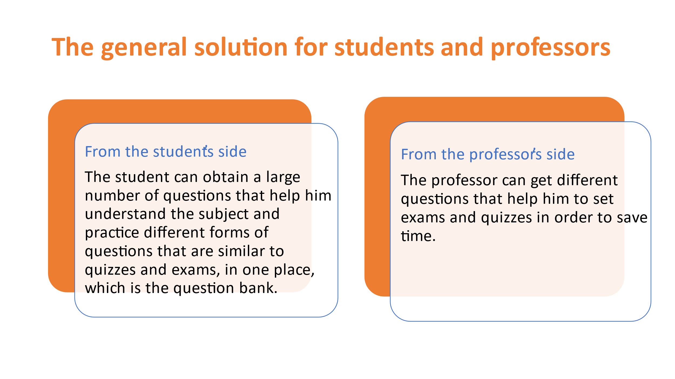

**1-The students:**

The question bank provides you with the various questions you need to understand your study materials. You practice the different types of questions that can be the subject of an exam without going to many sites that waste a lot of study time.

**2-professor and teacher:**

The question bank provides you with the various questions you need in setting different tests that cover all aspects of the subject. These questions have the same idea and different numbers, which helps you set equal tests for all students.

**To create a question bank that solves all problems, you must cover all aspects of the topic, including creating an electronic system, flowchart, and Algorithm for flowchart, pseudocode for flowchart:**

**2.2.1 Electronic system.**

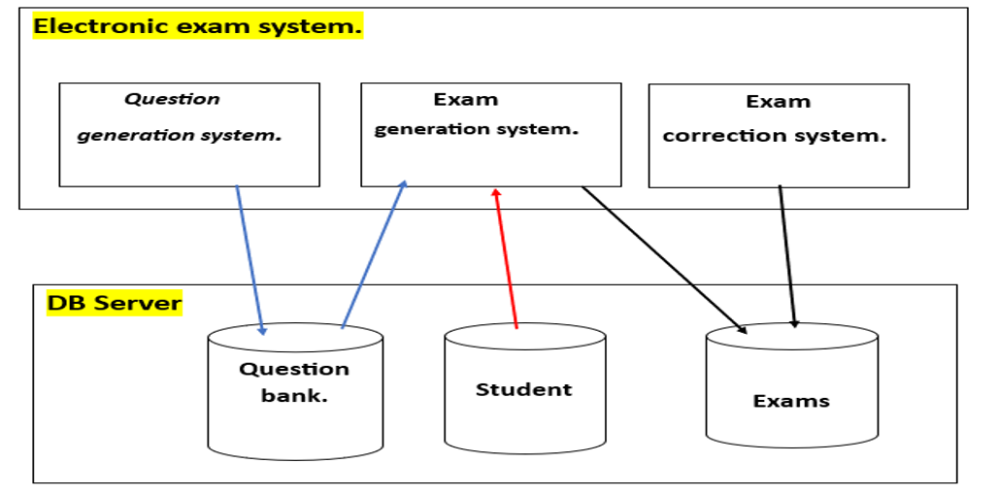

**Proposed from electronic system**: It is a complete diagram that explains every step within the question bank and consists of electronic exam system and database server.

**2.2.1 Electronic exam system:**

**1-Question generation systems:**

It is a system that creates questions and stores them in the database within the question bank.

**2-Exam generation system:**

The exam generation system conducts exams in general, as it takes the set of questions that were created within the database through the question bank.

It takes students' answers to the exam and then stores them in the database.

**3-Exam correction system:**

It is a system for automatic correction of student exams, as it stores students’ answers and then compares them with the correct exam model stored in the database.

**2.2.1 Database server:**

**1-Question Bank:**

It stores the questions created by the question generation system and then sends them to the exam generation system.

**2-Student:** Students solve questions stored within the exam generation system

**3-Exams.**

It stores all the exams taken by the students, which the system corrects in the following according to the exam pattern

**2.2.2 Flowchart**

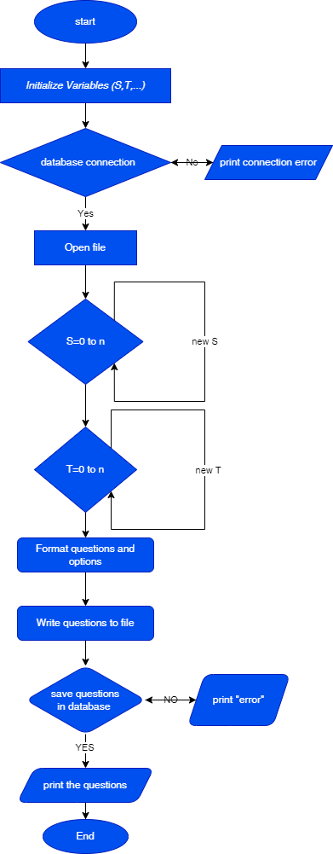

**2.2.3** **Algorithm for flowchart :**

Step1: start

Step2: Initialize variable (S,T, ...)

Step3 : database connection

Step 4 : no , go step5

Step 5 : print “connection error”

Step 6 yes, go step 7

Step 7 : open file

Step 8 : S=(0 to n)

Step 9 : T=(0 to n )

Step 10 : Format questions and operations

Step 11 : Write questions to file

Step 11 : Save questions in database

Step 12 : no, go to step 13

Step 13 : Prant “error”

Step 14 : yes, go to step 15

Step 15 : print the questions

Step 16 : End

**2.2.4 Pseudocode for Flowchart:**

Initialize variable (S,T ,....)

Connection database

Open file for writing

Using the for loop to create new variables for (S , T,…)

Format questions and operations

Save questions in database

Print the questions and finish the program

**Chapter 3**

**Project codes**

**This code is to link Java together with JDBC:**

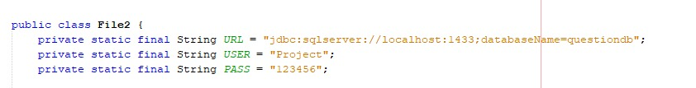

**This code creates a table:**

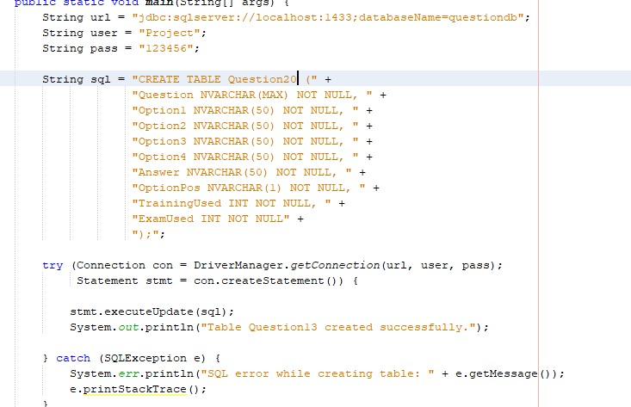

**The Questions:**

**1-Question (1):**

**This code is used to create questions that calculates average velocity based on distance and time:**

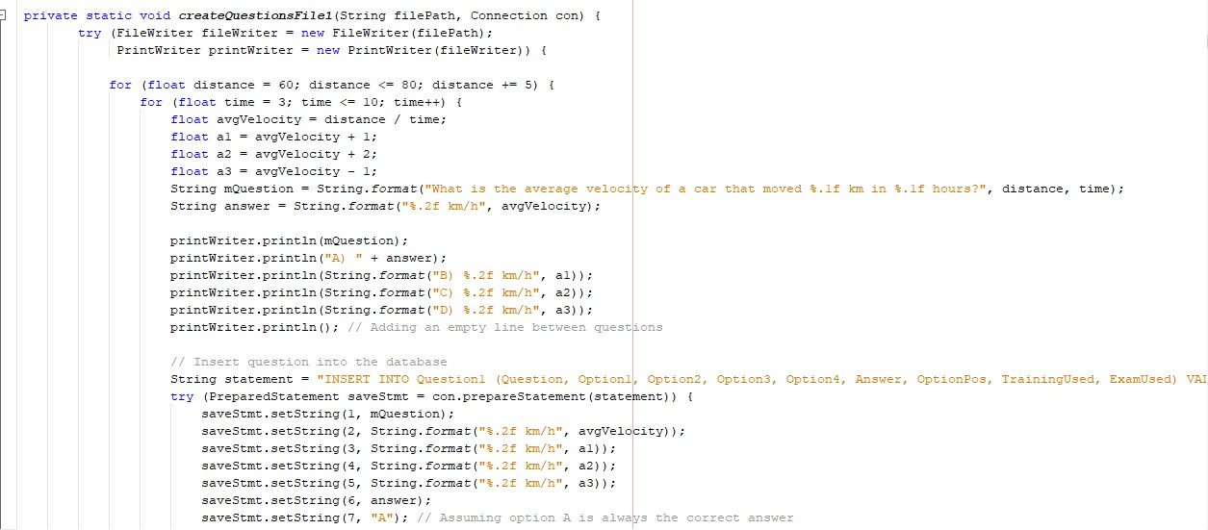

**Output question (1):**

**This is the output of save the code in database that calculates average velocity based on distance and time:**

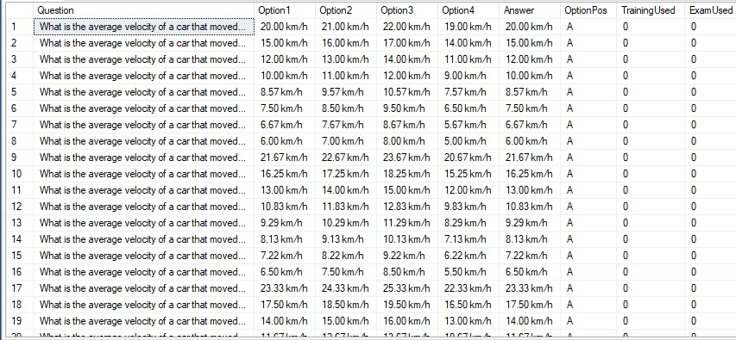

**Output question (1) in text file:**

**Output question (13) in text file that calculates average velocity based on distance and time:**

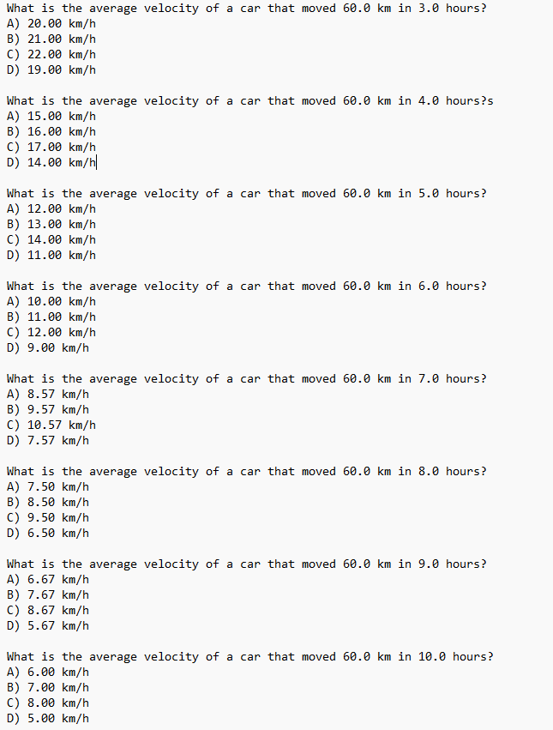

**2-Question (2)**

**This code is used to create questions that Calculates accelerates based on distance and time:**

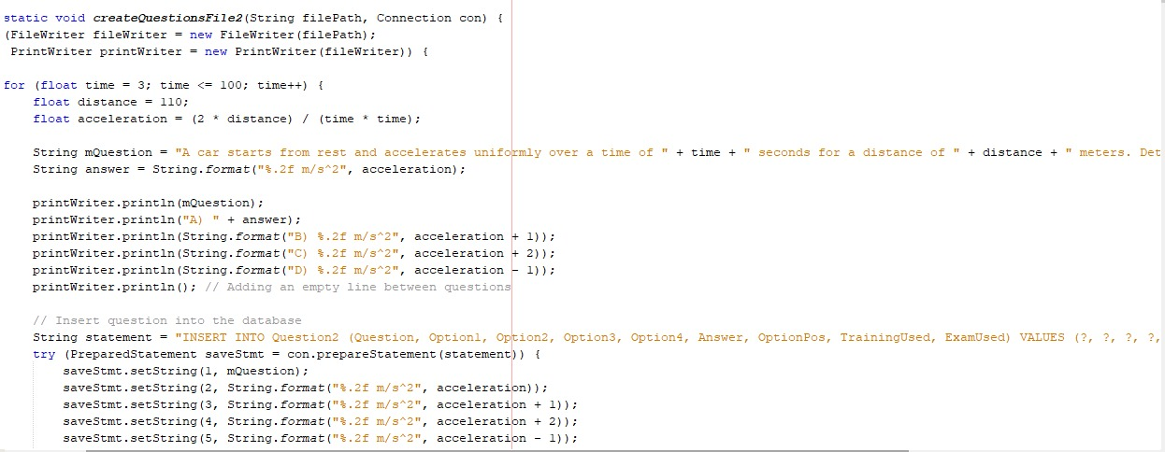

**Output question (2):**

**This is the output of save the code in database that calculates accelerates based on distance and time:**

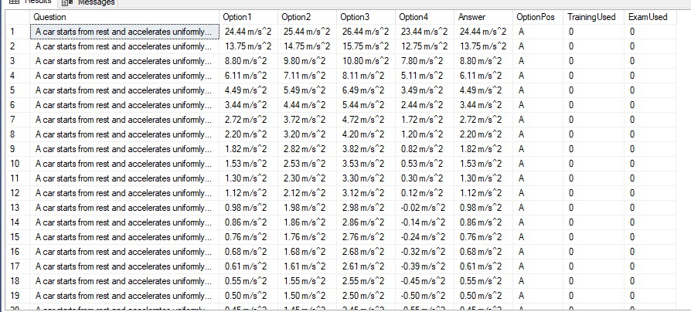

**Output question (2) in text file:**

**Output question (2) in text file that calculates accelerates based on distance and time:**

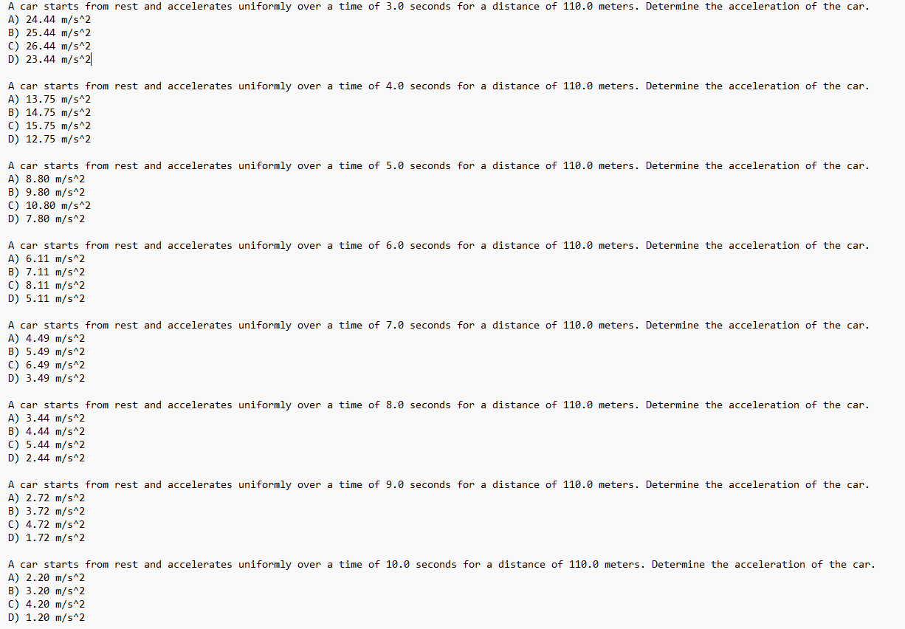

**3-Question (3):**

**This code is used to create questions that calculates accelerates based on variable velocity and variable time:**

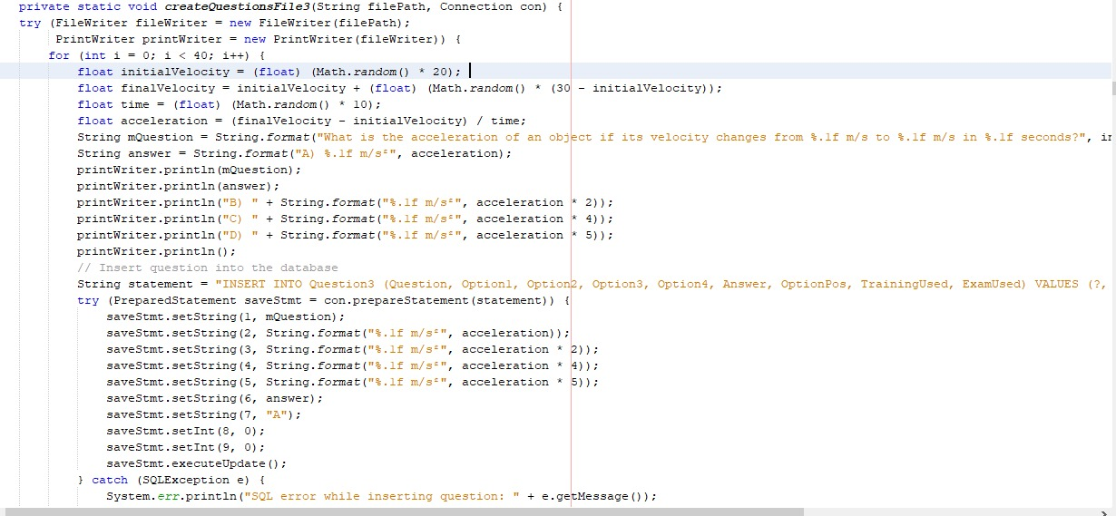

**Output question (3):**

**This is the output of save the code in database that calculates accelerates based on variable velocity and variable time:**

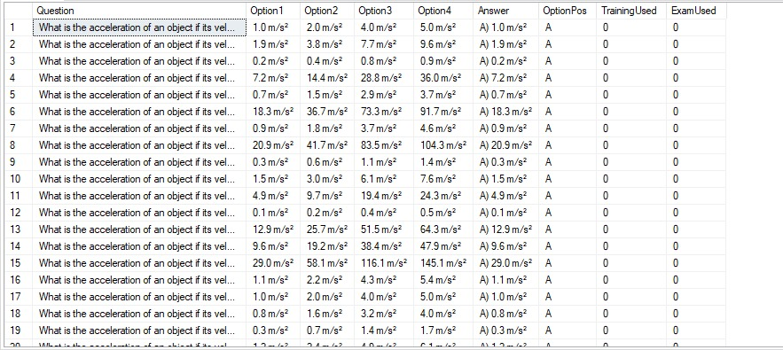

**Output question (3) in text file:**

**Output question (3) in text file that calculates accelerates based on variable velocity and variable time:**

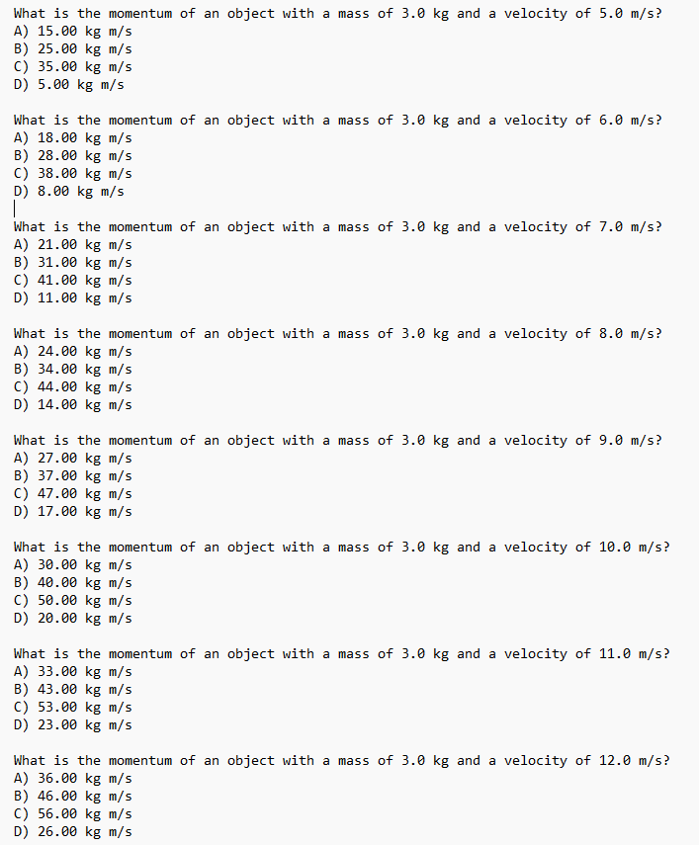

**4-Question (4):**

**This code is used to create questions that calculates distance based on accelerates and time:**

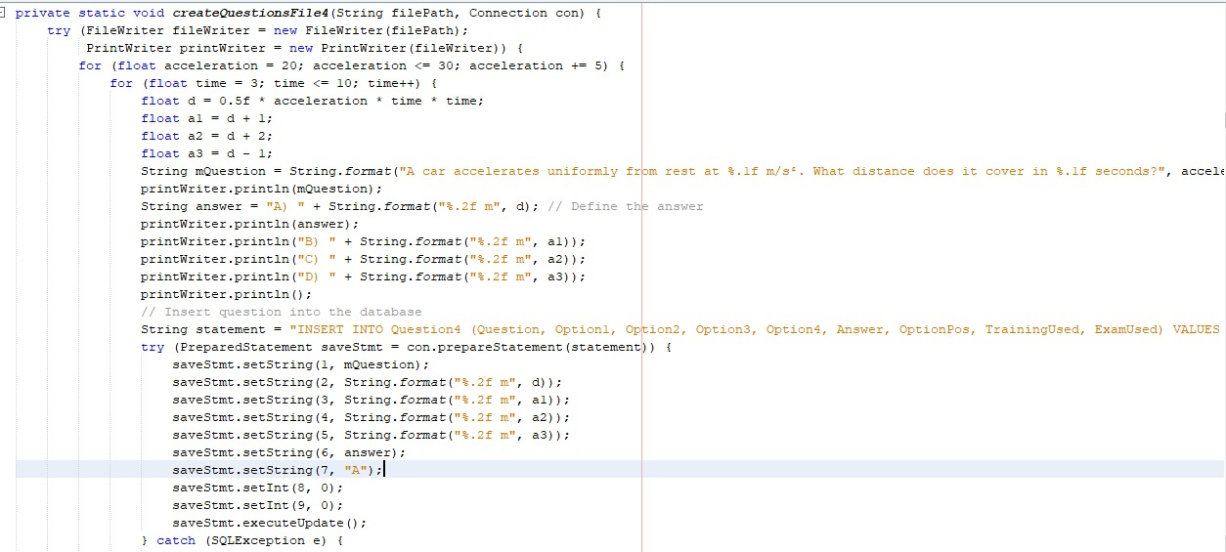

**Output question (4):**

**This is the output of save the code in database that calculates distance based on accelerates and time:**

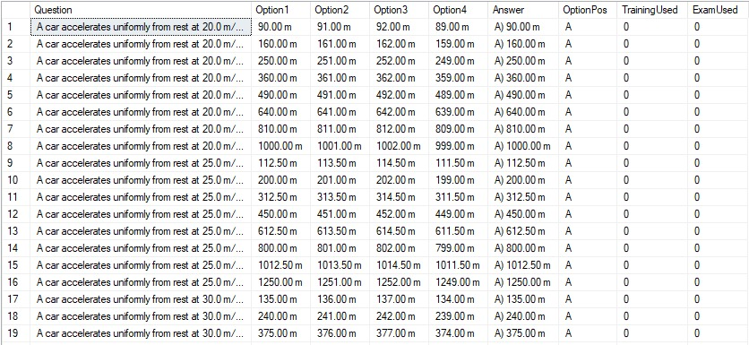

**Output question (4) in text file:**

**Output question (4) in text file that calculates distance based on accelerates and time:**

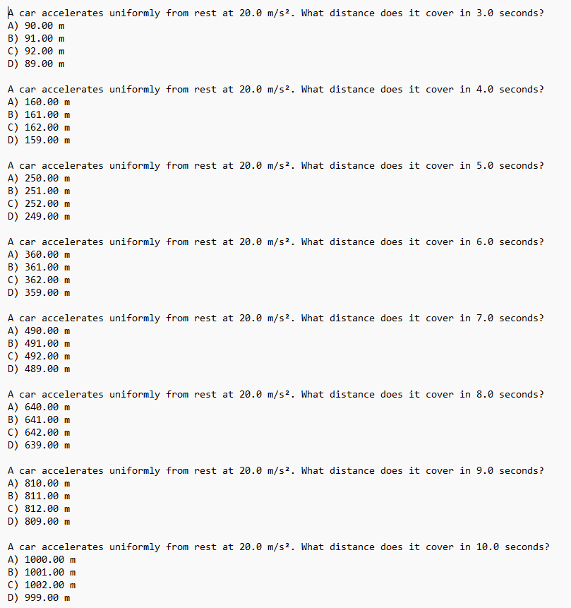

**5-Question (5):**

**This code is used to create questions that calculates distance based on time and the equation of motion for uniformly accelerated motion:**

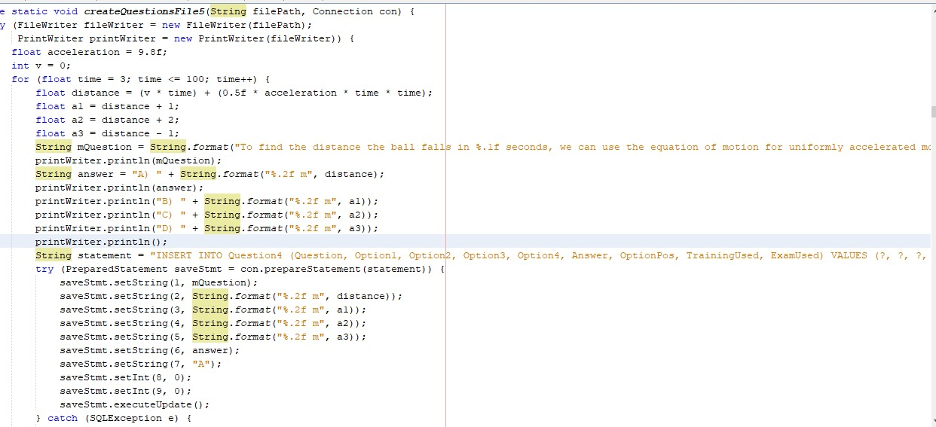

**Output question (5):**

**This is the output of save the code in database that Calculates distance based on time and the equation of motion for uniformly accelerated motion:**

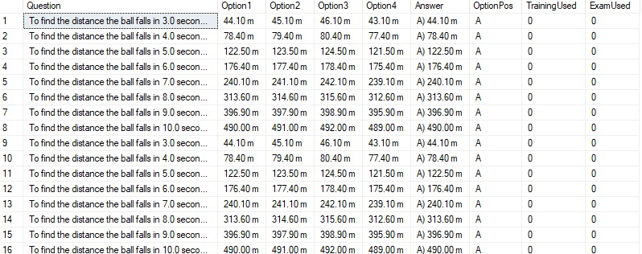

**Output question (5) in text file:**

**Output question (5) in text file that Calculates distance based on time and the equation of motion for uniformly accelerated motion:**

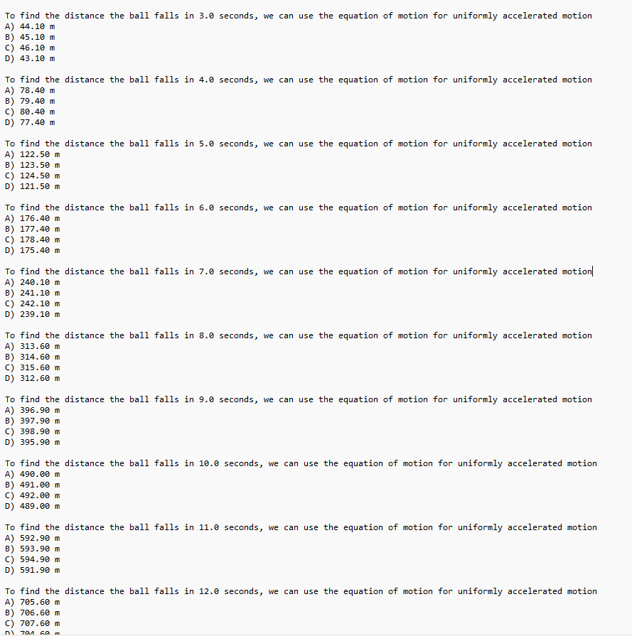

**6-Question (6):**

**This code is used to create questions that calculates velocity based on accelerates uniformly and time:**

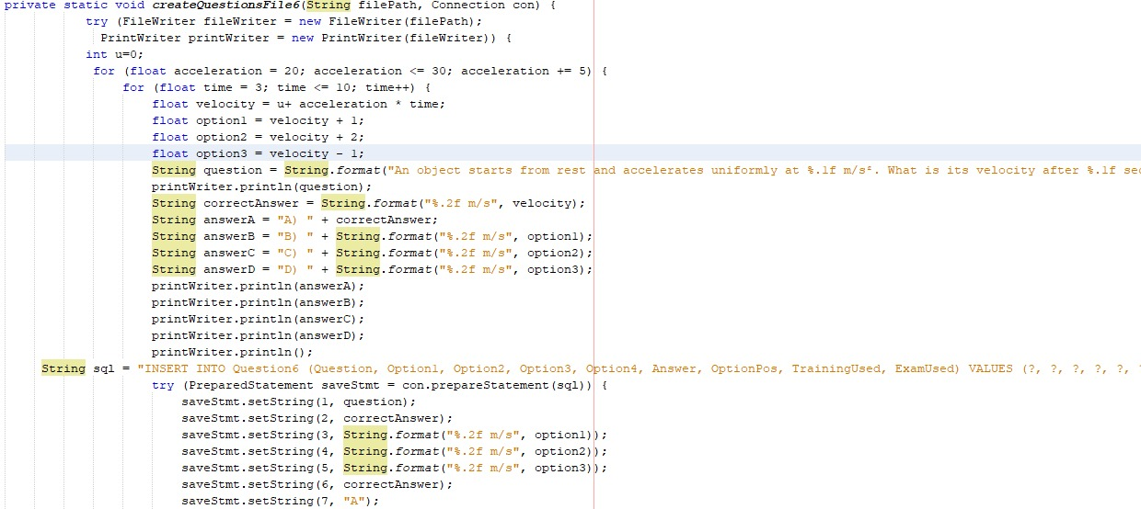

**Output question (6):**

**This is the output of save the code in database that calculates velocity based on accelerates uniformly and time:**

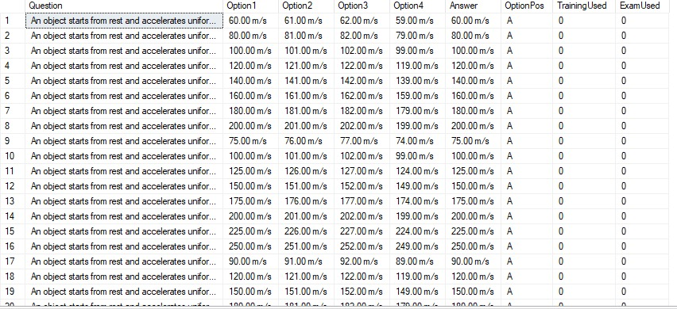

**Output question (6) in text file:**

**Output question (6) in text file that calculates velocity based on accelerates uniformly and time:**

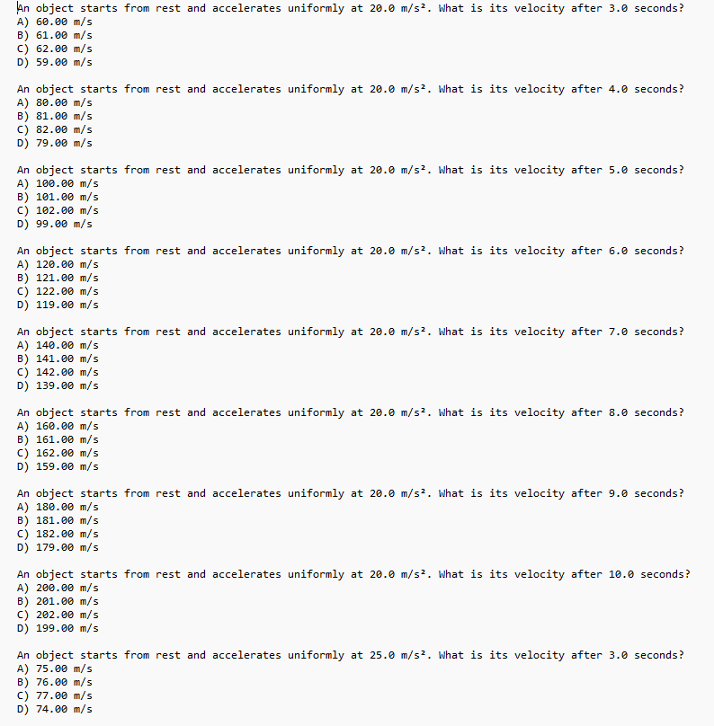

**7-Question (7):**

**This code is used to create questions that calculates acceleration based on force and mass:**

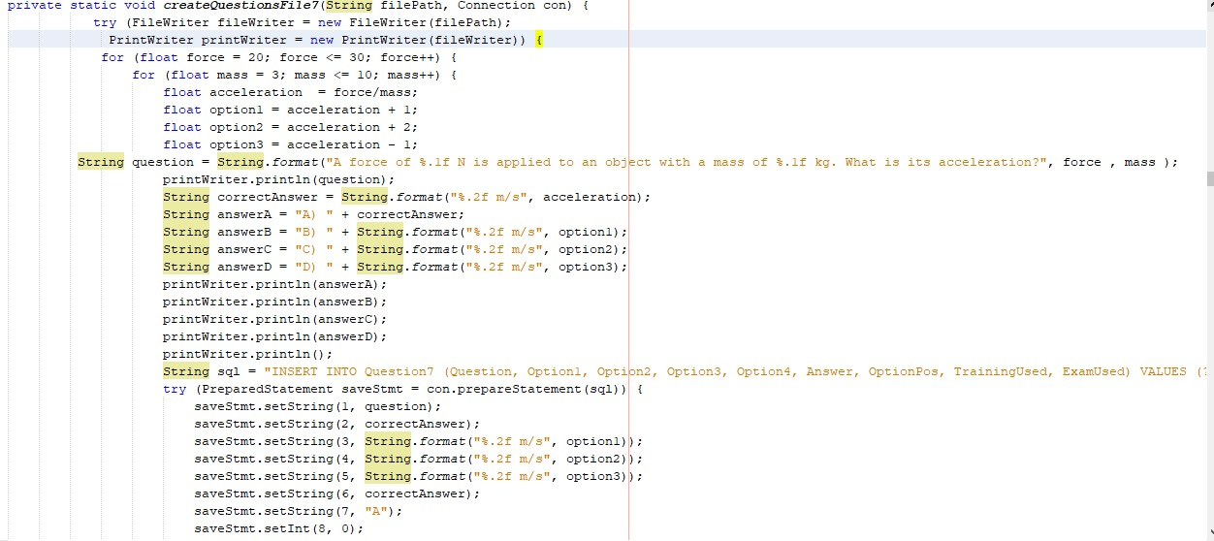

**Output question (7):**

**This is the output of save the code in database that calculates acceleration based on force and mass:**

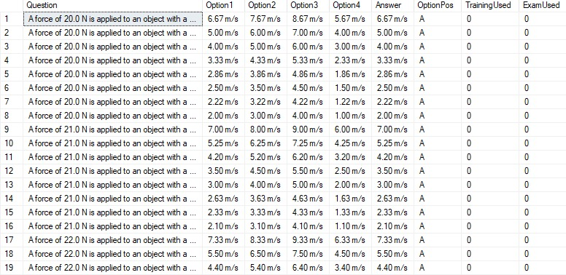

**Output question (7) in text file:**

**Output question (7) in text file that calculates acceleration based on force and mass:**

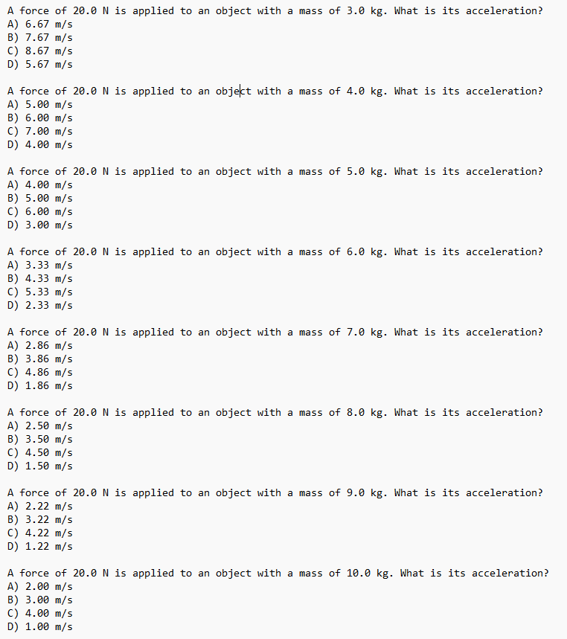

**8-Question (8):**

**This code is used to create questions that calculates velocity based on initial velocity and time:**

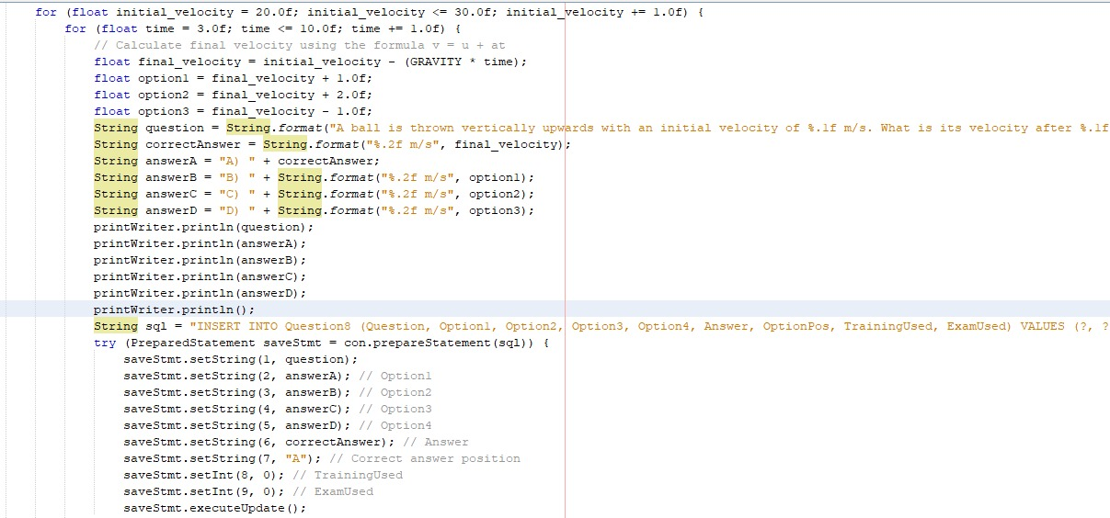

**Output question (8):**

**This is the output of save the code in database that calculates velocity based on initial velocity and time:**

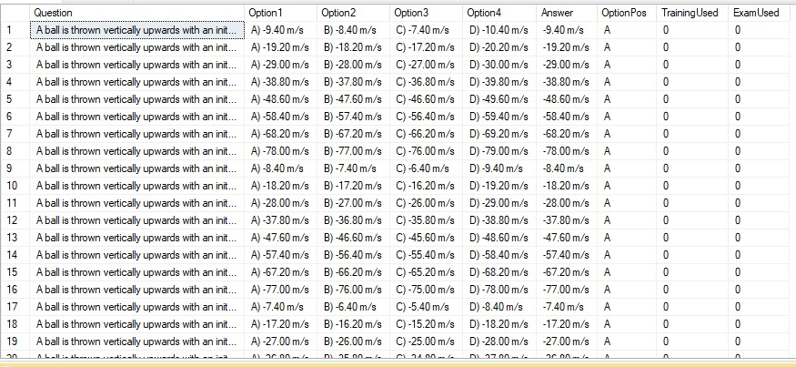

**Output question (8) in text file:**

**Output question (8) in text file that calculates velocity based on initial velocity and time:**

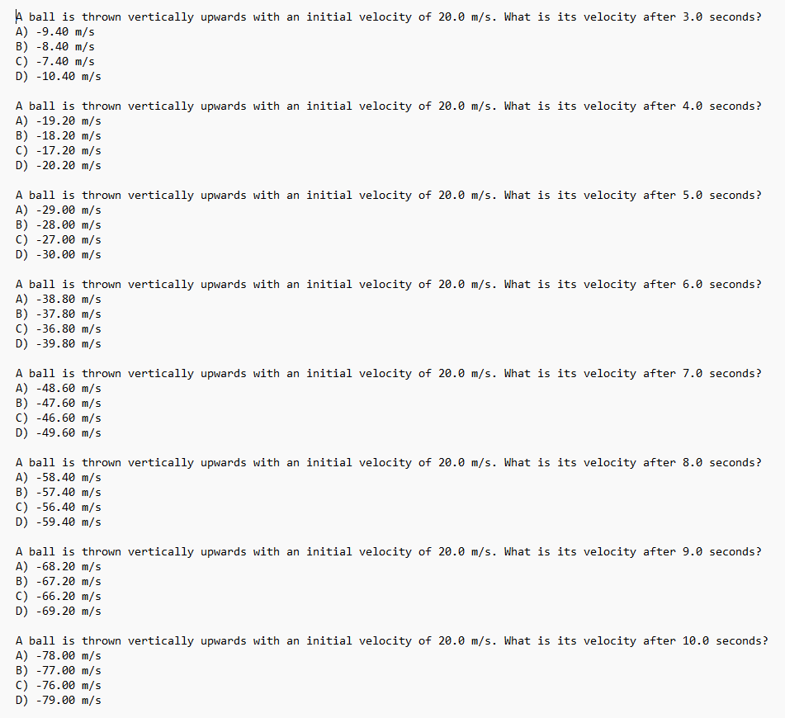

**9-Question (9):**

**This code is used to create questions that calculates distance based on initial velocity and time:**

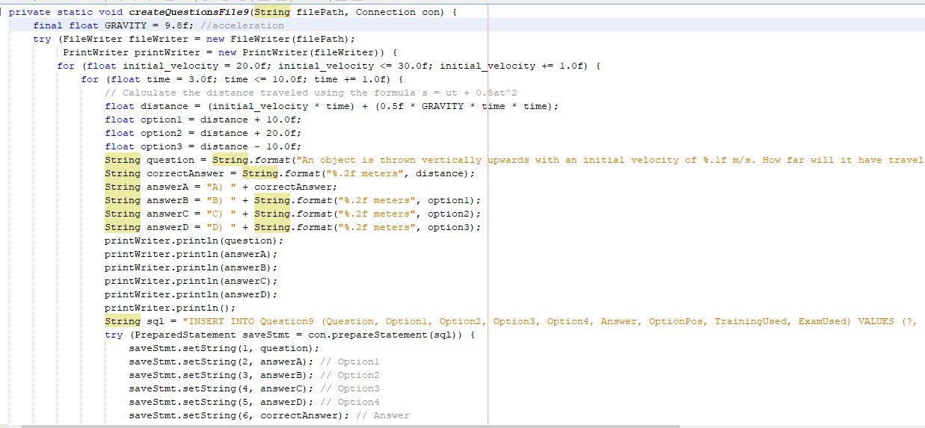

**Output question (9):**

**This is the output of save the code in database that calculates distance based on initial velocity and time:**

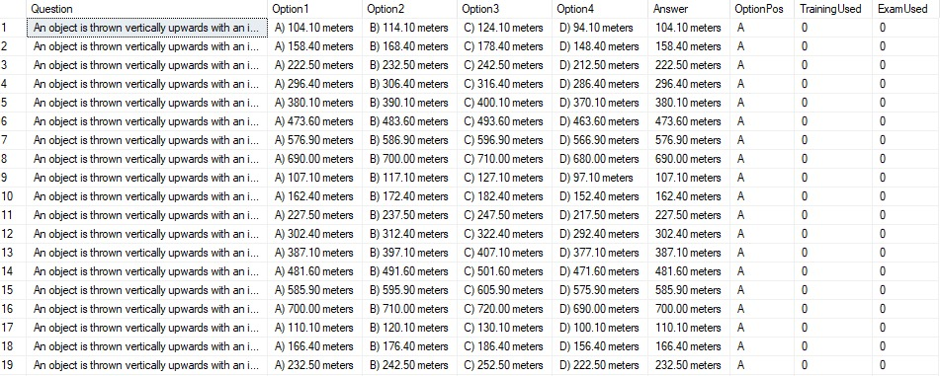

**Output question (9) in text file:**

**Output question (9) in text file that calculates distance based on initial velocity and time:**

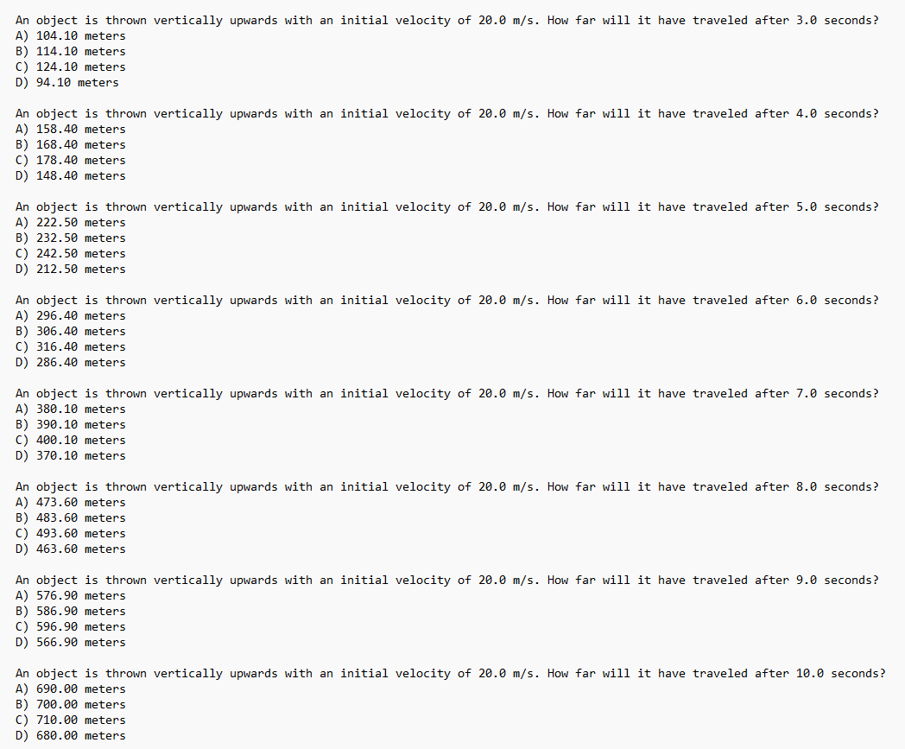

**10-Question (10):**

**This code is used to create questions that calculates kinetic energy based on mass and velocity:**

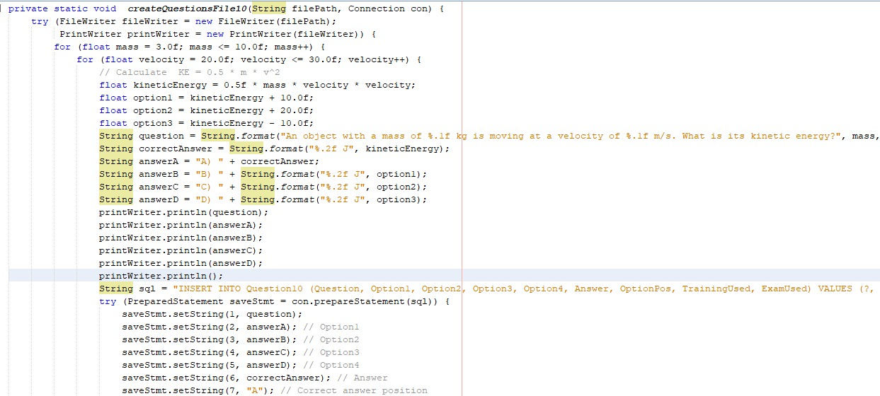

**Output question (10):**

**This is the output of save the code in database that calculates kinetic energy based on mass and velocity:**

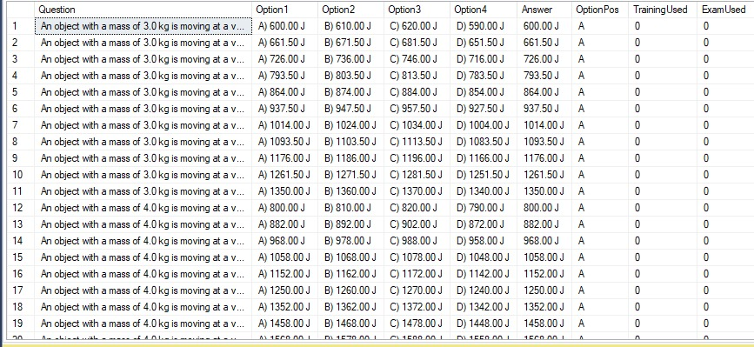

**Output question (10) in text file:**

**Output question (10) in text file that calculates kinetic energy based on mass and velocity:**

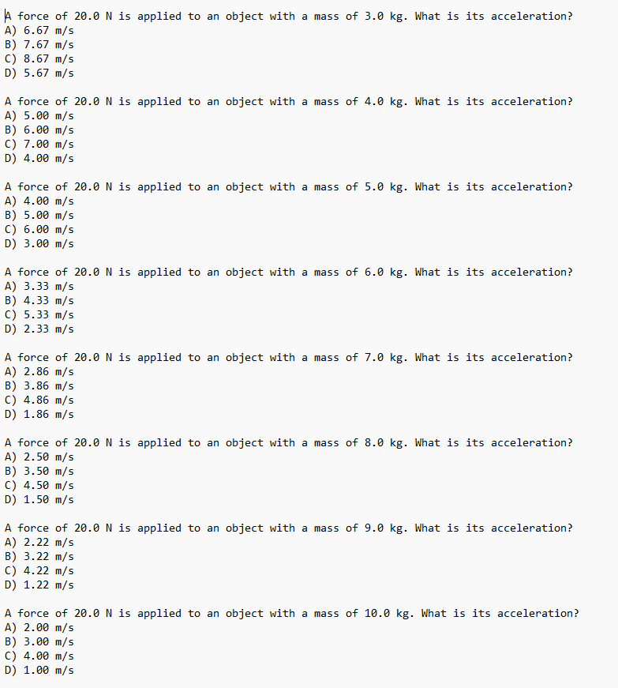

**11-Question (11):**

**This code is used to create questions that calculates potential based on mass and height:**

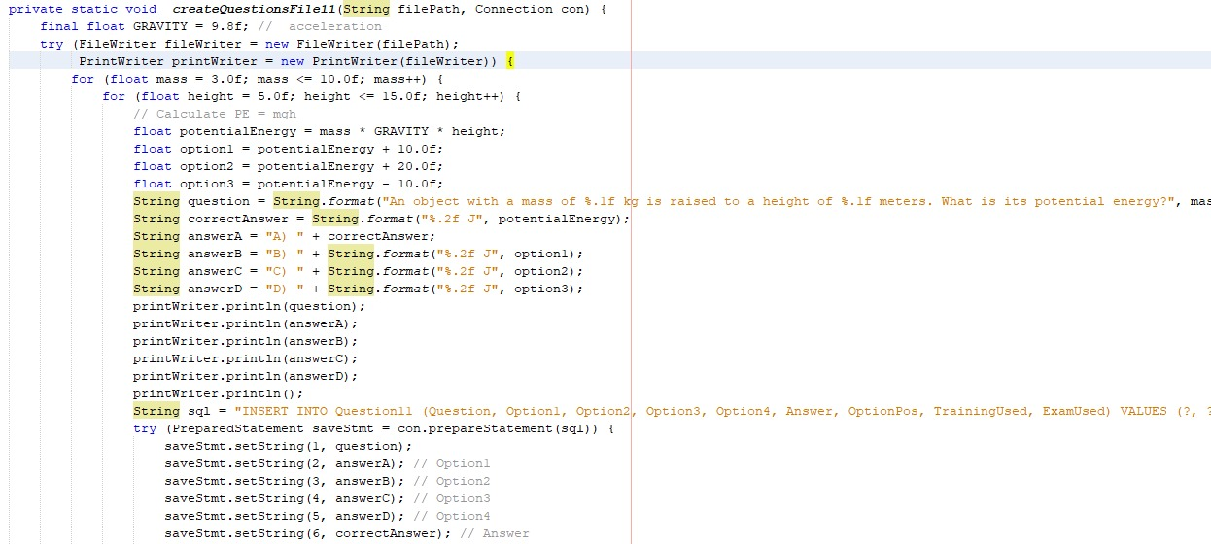

**Output question (11):**

**This is the output of save the code in database that calculates potential based on mass and height:**

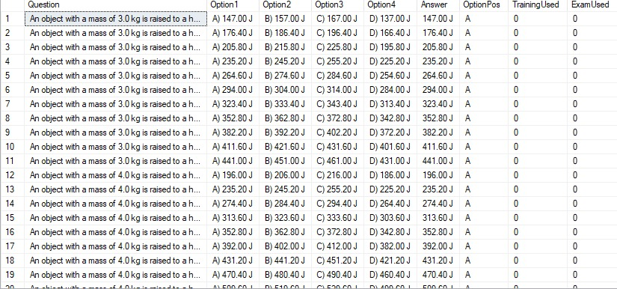

**Output question (11) in text file:**

**Output question (11) in text file that calculates potential based on mass and height:**

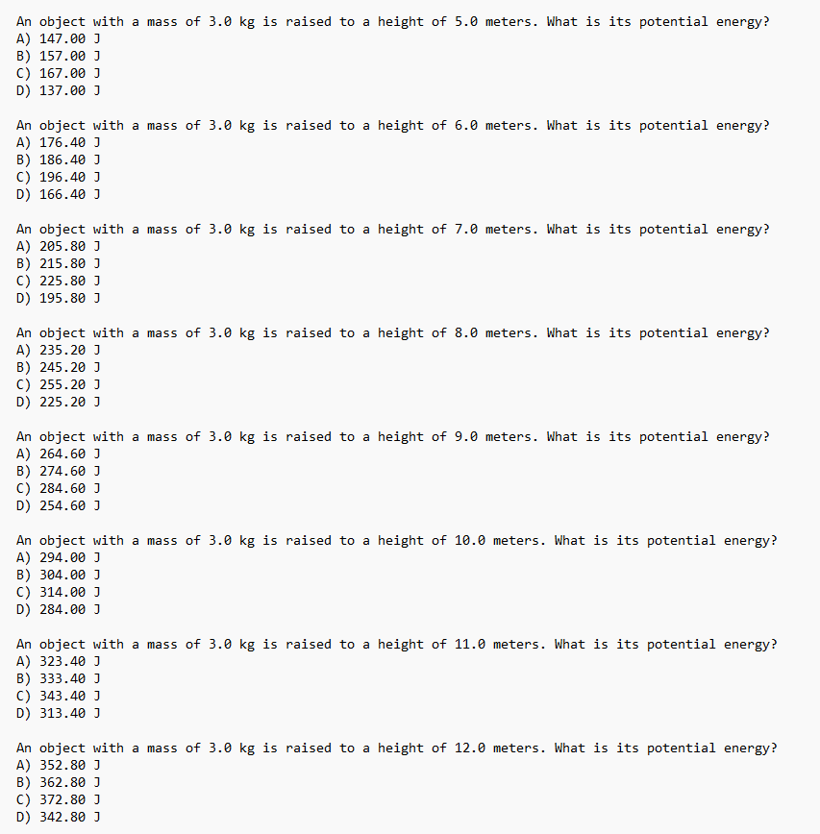

**12-Question (12):**

**This code is used to create questions that calculates the work done based on force and distance an angle:**

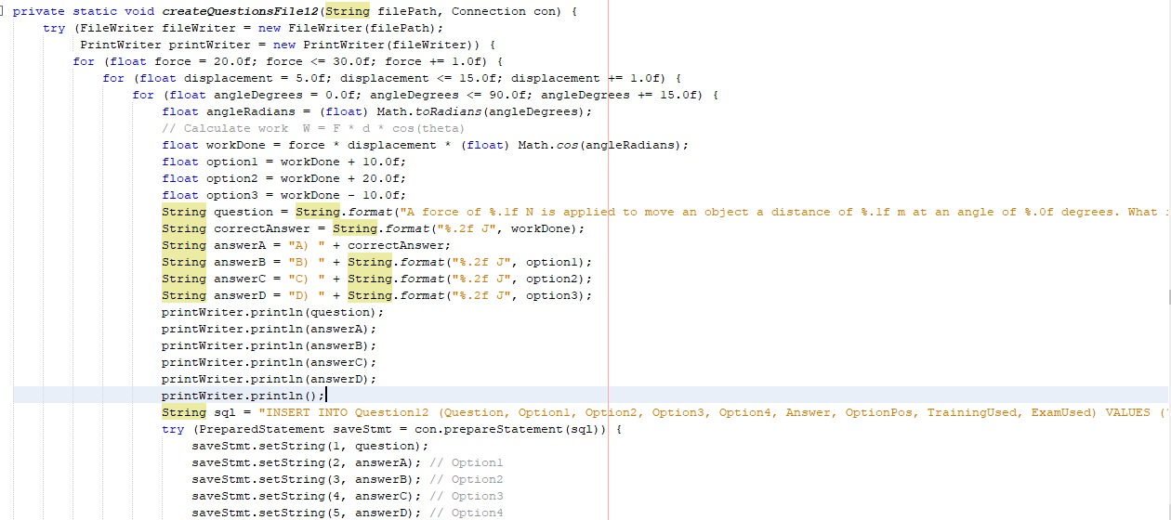

**Output question (12):**

**This is the output of save the code in database that calculates the work done based on force and distance an angle:**

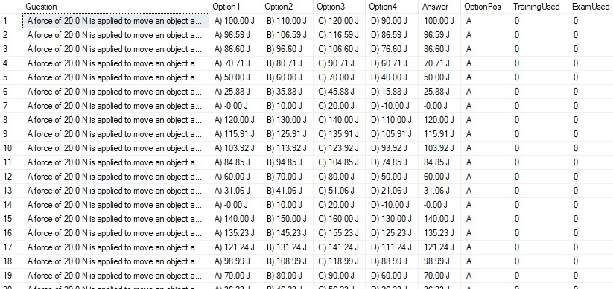

**Output question (12) in text file:**

**Output question (12) in text file that calculates the work done based on force and distance an angle:**

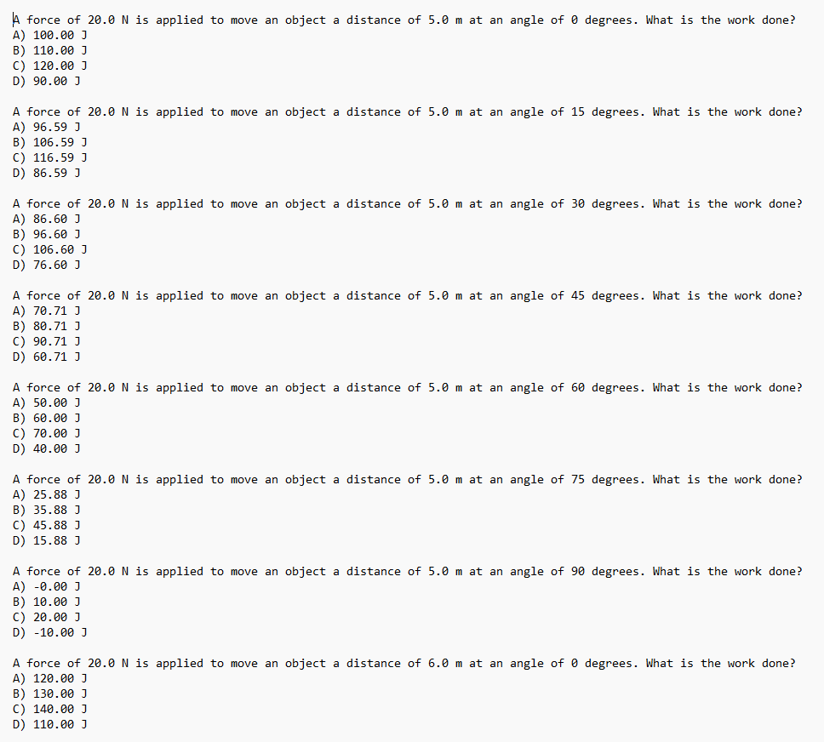

**13-Question (13):**

**This code is used to create questions that calculates the momentum based on mass and velocity:**

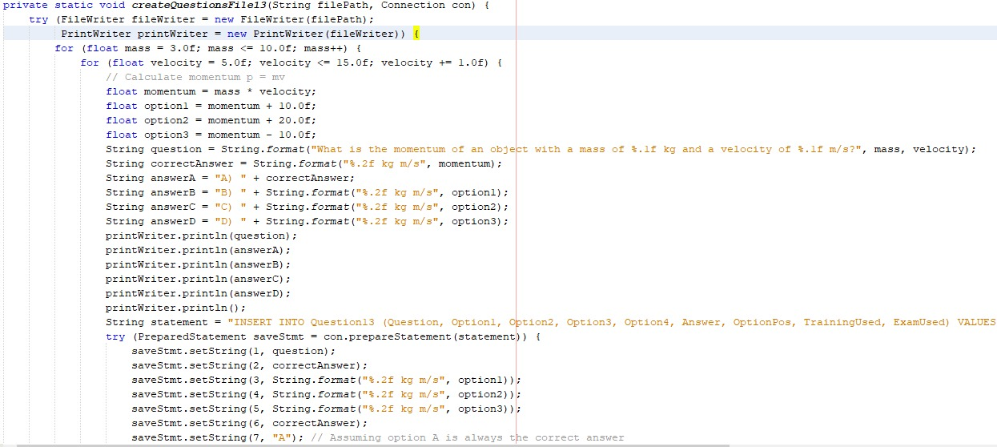

**Output question (13):**

**This is the output of save the code in database that calculates the momentum based on mass and velocity:**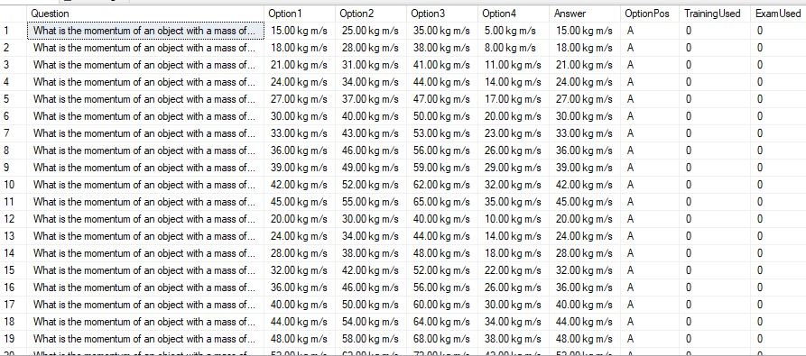

**Output question (13) in text file:**

**Output question (13) in text file that calculates the momentum based on mass and velocity:**

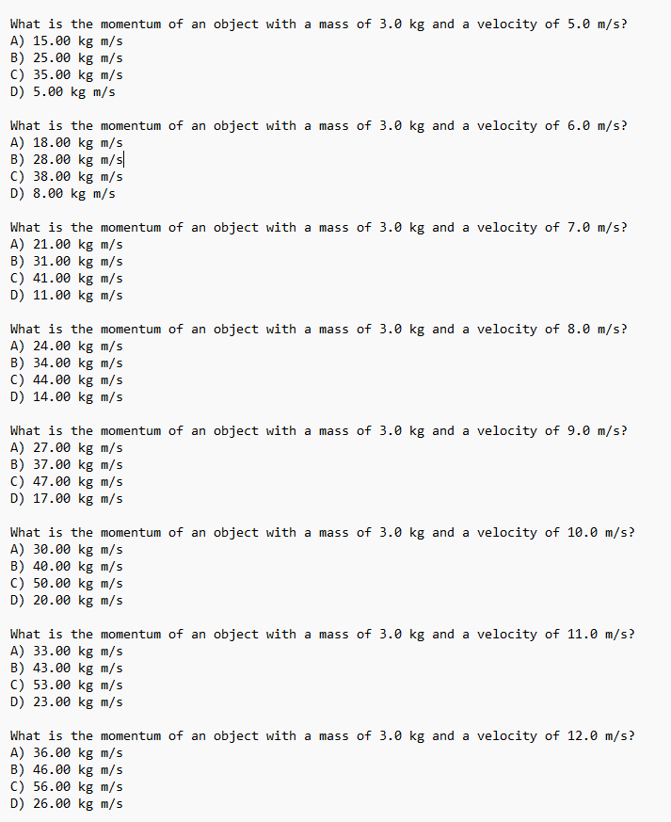

**14-Question (14):**

**This code is used to create questions that calculates power based on work and time:**

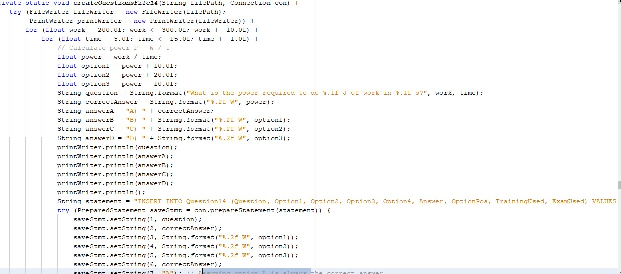

**Output question (14):**

**This is the output of save the code in database that calculates power based on work and time:**

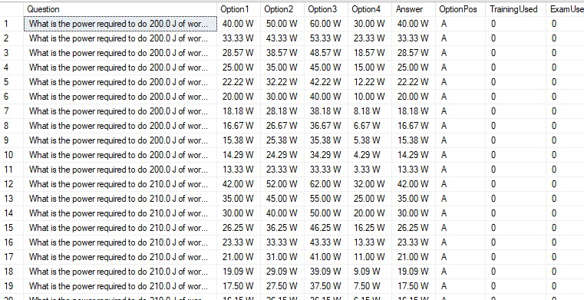

**Output question (14) in text file:**

**Output question (14) in text file that calculates power based on work and time:**

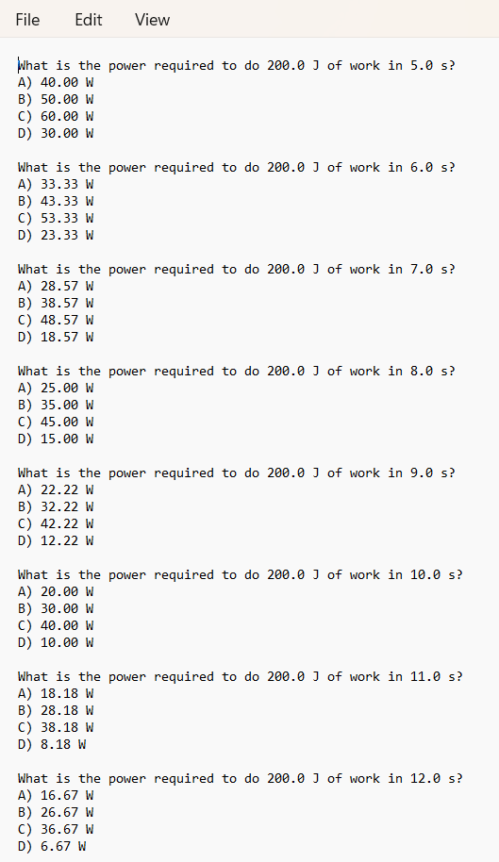

**15-Question (15):**

**This code is used to create questions that calculates kinetic energy based on mass and velocity:**

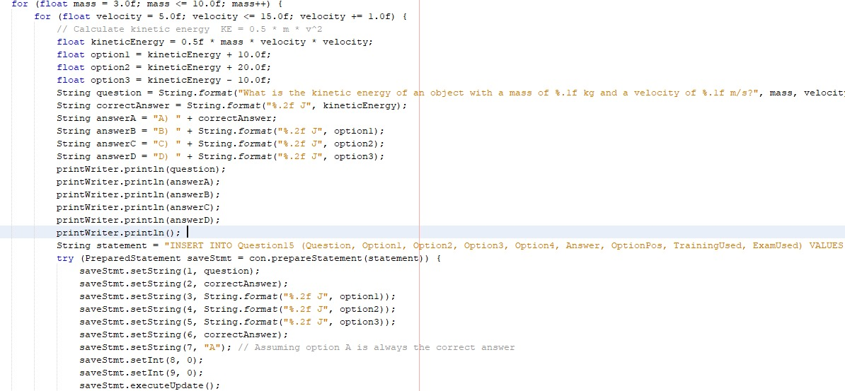

**Output question (15):**

**This is the output of save the code in database that calculates kinetic energy based on mass and velocity:**

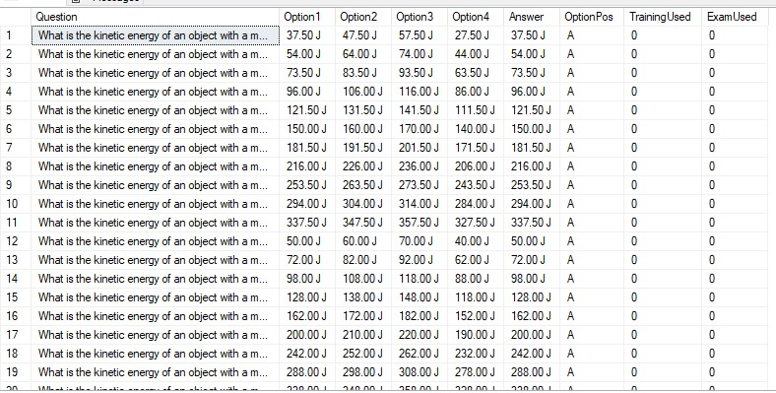

**Output question (15) in text file:**

**Output question (15) in text file that calculates kinetic energy based on mass and velocity:**

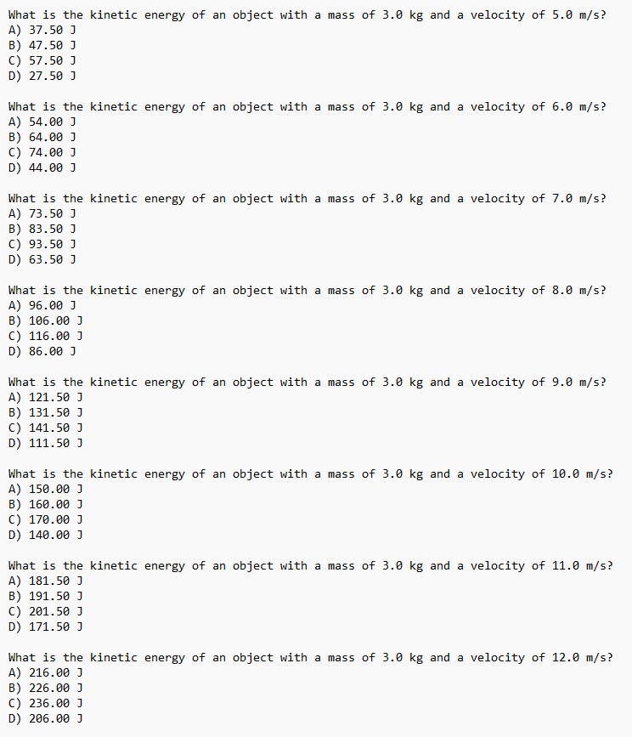

**16-Question (16):**

**This code is used to create questions that calculates the density based on mass and volume:**

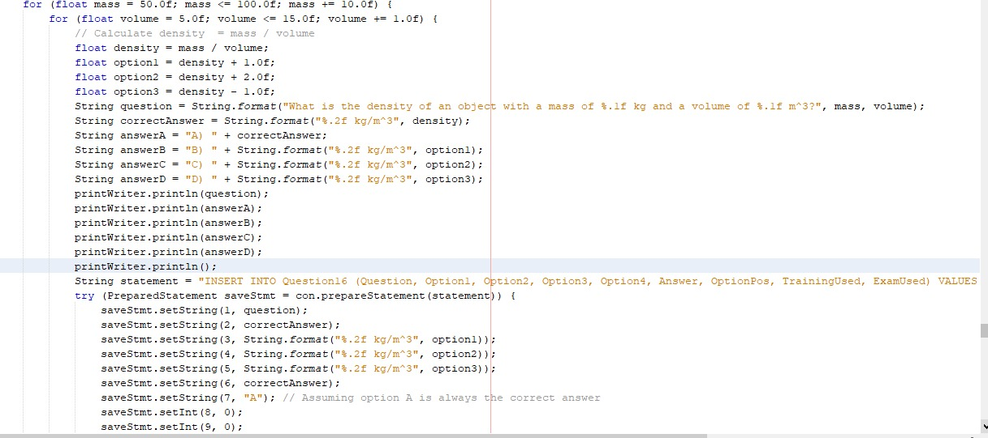

**Output question (16):**

**This is the output of save the code in database that calculates the density based on mass and volume:**

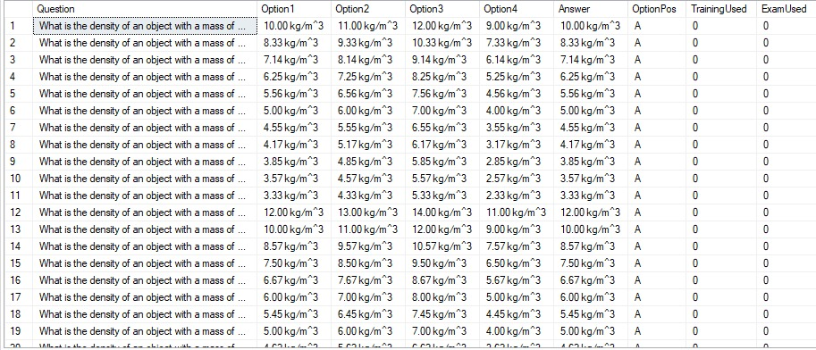

**Output question (16) in text file:**

**Output question (16) in text file that calculates the density based on mass and volume:**

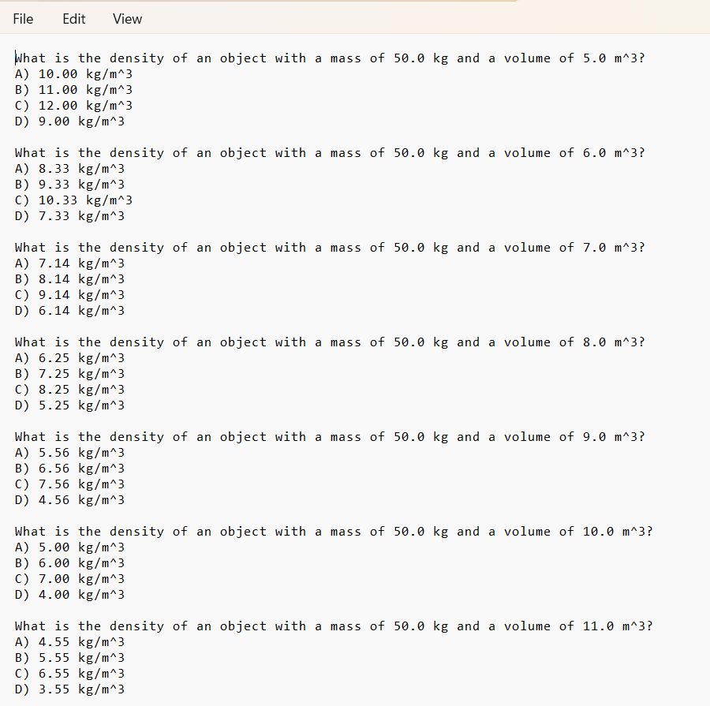

**17-Question (17):**

**This code is used to create questions that calculates the pressure based on force and area:**

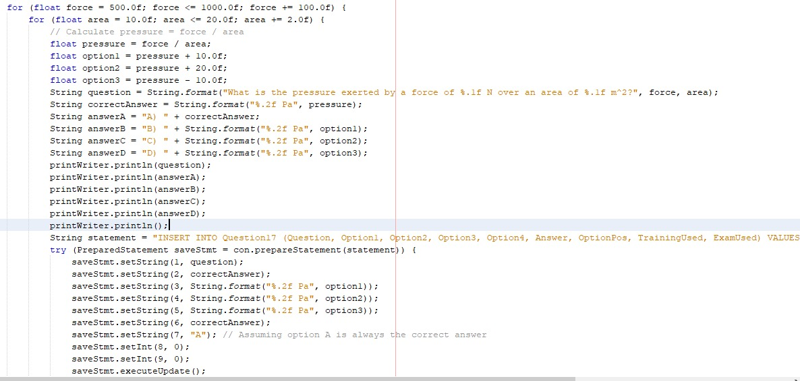

**Output question (17):**

**This is the output of save the code in database that calculates the pressure based on force and area:**

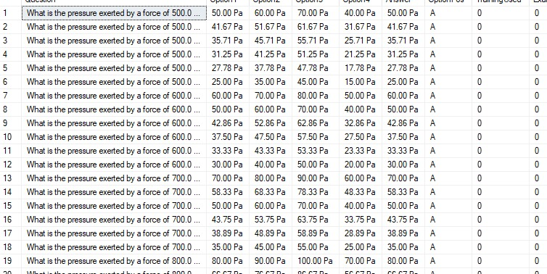

**Output question (17) in text file:**

**Output question (17) in text file that calculates the pressure based on force and area:**

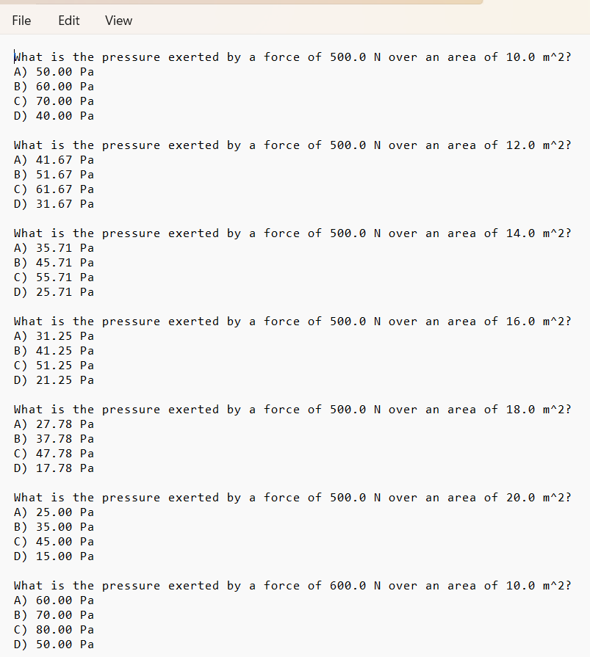

**18-Question (18):**

**This code is used to create questions that calculates**

**Work based on force and distance:**

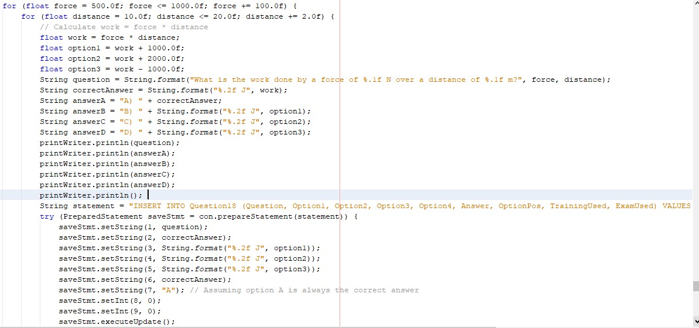

**Output question (18):**

**This is the output of the code that calculates the Work based on force and distance:**

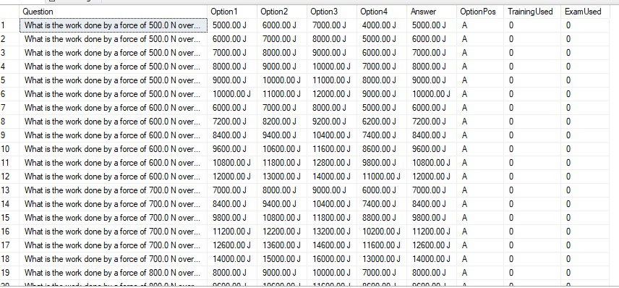

**Output question (18) in text file:**

**Output question (18) in text file that calculates the Work based on force and distance:**

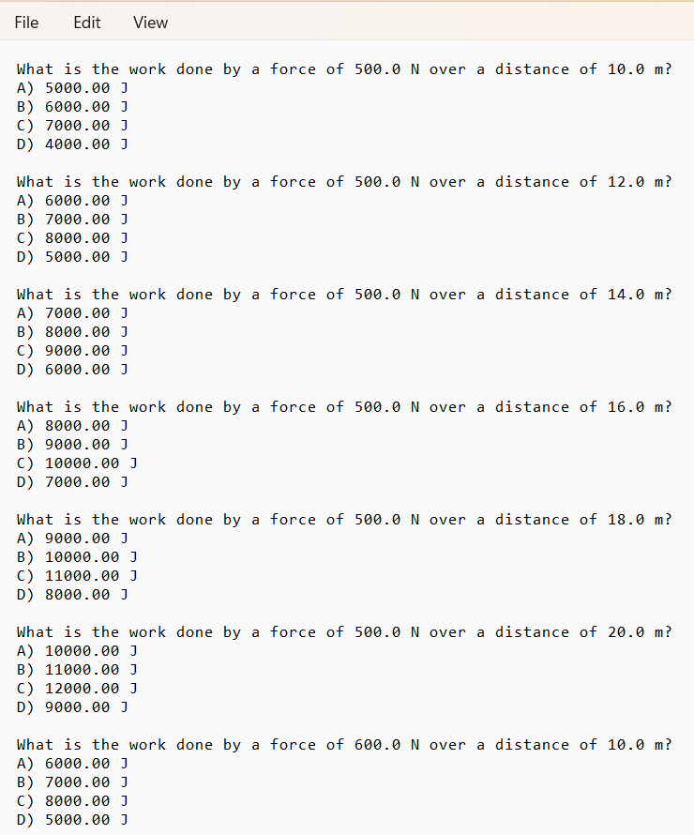

**19-Question (19):**

**This code is used to create questions that calculates the electric current based on voltage and resistance:**

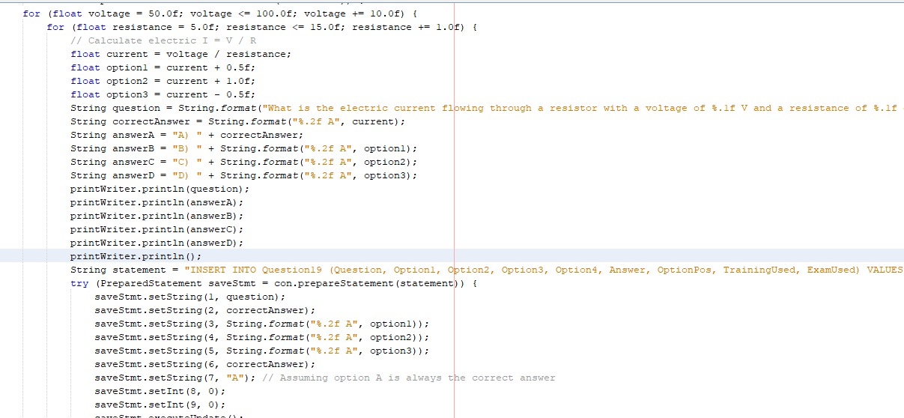

**Output question (19):**

**This is the output of save the code in database that calculates the electric current based on voltage and resistance:**

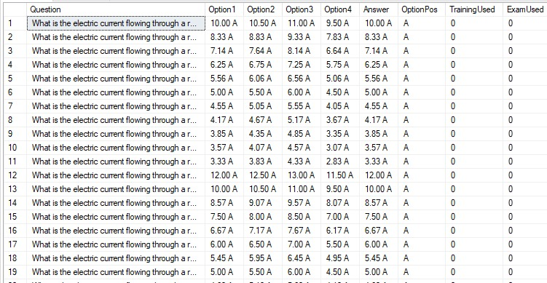

**Output question (19) in text file:**

**Output question (19) in text file that calculates the electric current based on voltage and resistance:**

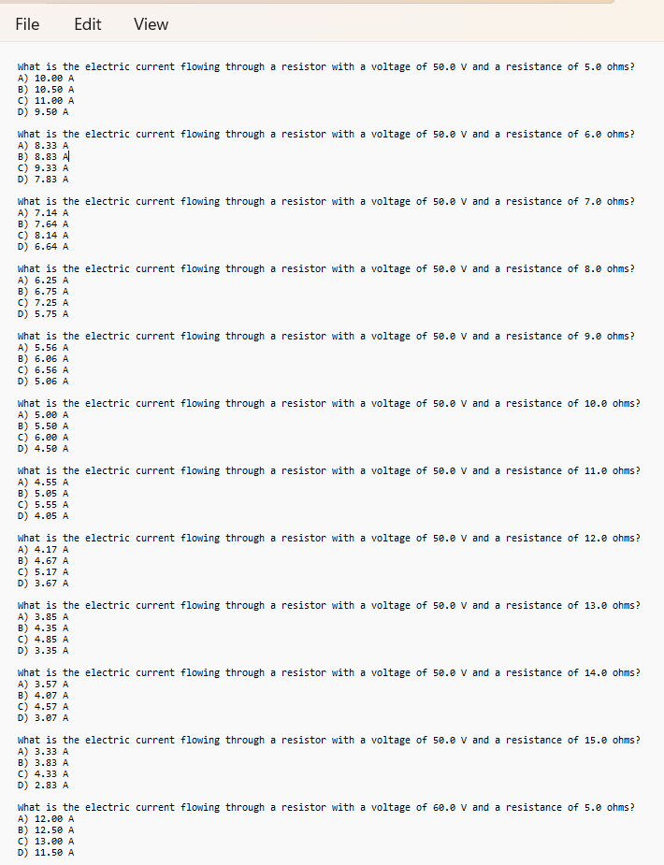

**Conclusion and Future Work**

**5.1Conclusion:**

The question bank generation system represents an important step towards improving the learning and teaching process. With its ability to quickly and effectively generate diverse sets of questions, this system can help enhance students' engagement with educational materials and enhance critical and creative thinking skills. In addition, reducing the effort and time required to prepare questions can improve the efficiency of teachers and trainers. However, developers and interested parties must continue to work on developing and improving this system, focusing on providing new features and improvements to the user interface and accuracy of question production. By investing in this area, we can make sustainable progress in improving the quality of education and supporting the development of skills needed for students in the age of technology.

**5.2 Future Work:**

In the future, we will develop the question bank to resemble Moodle, and we can also integrate artificial intelligence to enhance its flexibility and user-friendliness, thereby saving time and effort.